QuickBite

End-to-End Food Delivery Database System
DBMS Mini Project Report
B.Tech CSE-CSF • A - 1
Submitted by
Name | PRN
Miraya Ballav | 1262251072
Drishti Parashar | 1262250911
Saksham Jain | 1262250842
Ayush Manjrekar | 1262251824

Abstract
QuickBite is an academic relational database system that models the food-ordering lifecycle: customers, restaurants, menus, orders, payments, delivery and reviews. Its 11 normalized tables are linked by primary and foreign keys to reduce redundancy, keep order and payment states consistent, and support JOIN-based reporting. The project demonstrates core SQL features, views, triggers, stored procedures and transactions, with a small C console prototype of the ordering flow.

Introduction
Problem statement. Without a normalized database design, food-delivery platforms suffer from data duplication, inconsistent order and payment states, and slow multi-table retrieval for reporting and analytics.
Objectives
- Manage customers and their addresses
- Model restaurants, categories and food items
- Track orders, order items, payments and deliveries
- Store customer reviews and ratings
- Demonstrate SQL features: DDL , DML , joins and constraints
System modules: Customer Management, Restaurant Management, Menu Management, Order Management, Payment Management, Delivery Management, and Review & Rating.
Order flow: Customer → Restaurant → Menu → Food Items → Order → Payment → Restaurant Processing → Delivery Partner → Delivered → Review.

ER Diagram
The ER diagram is built from the following relationships (primary key → foreign key):
Parent entity | Child entity | Linking attribute
CUSTOMER | ADDRESS | customer_id
CUSTOMER | ORDERS | customer_id
RESTAURANT | FOOD_ITEM | restaurant_id
CATEGORY | FOOD_ITEM | category_id
ORDERS | ORDER_ITEM | order_id
FOOD_ITEM | ORDER_ITEM | item_id
ORDERS | PAYMENT | order_id
ORDERS | DELIVERY | order_id
DELIVERY_PARTNER | DELIVERY | partner_id
CUSTOMER, RESTAURANT, ORDERS | REVIEW | customer_id, restaurant_id, order_id
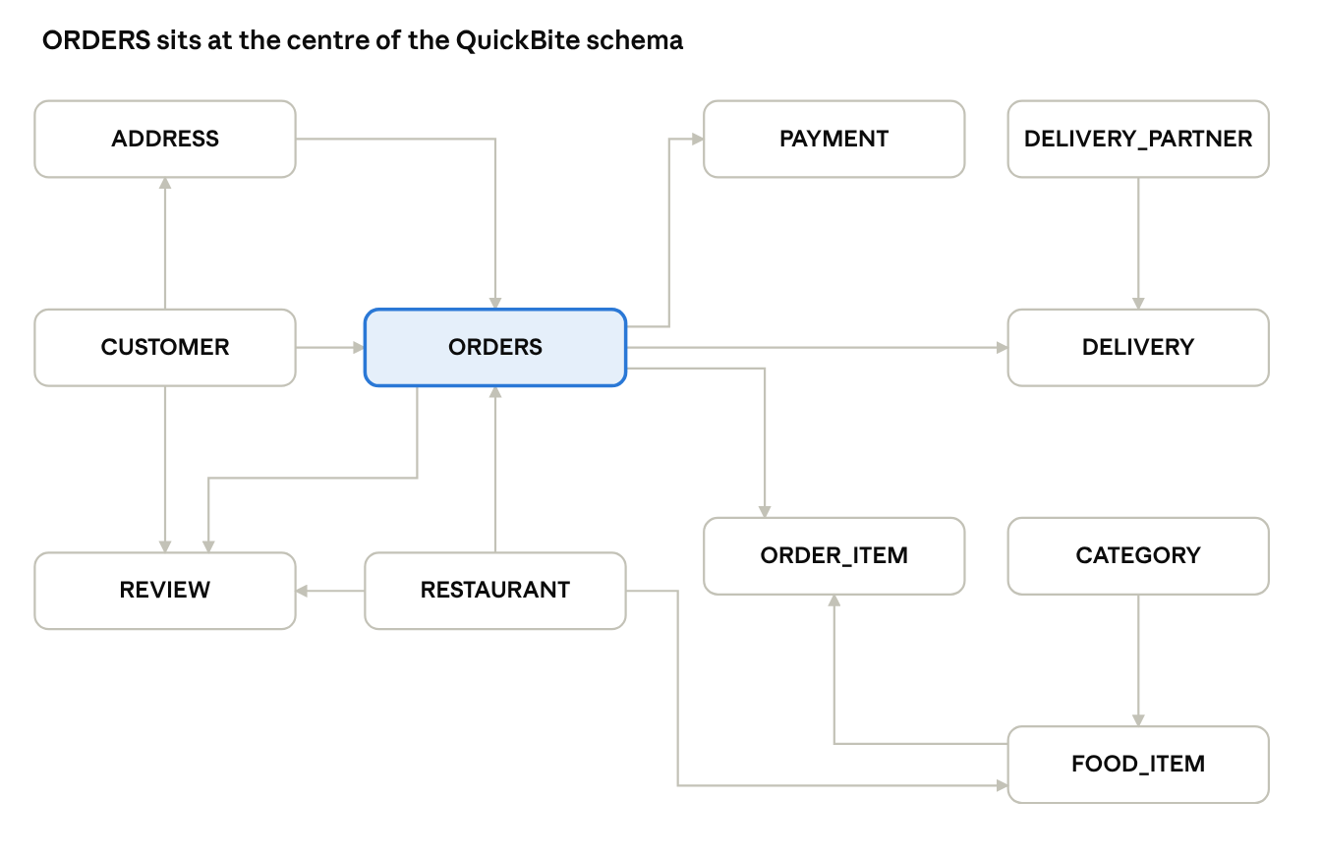
QuickBite ER diagram · 11 tables, primary key to foreign key
Each arrow runs from the table holding the primary key to the table holding the foreign key; ORDERS links customers, addresses, restaurants, items, payments, deliveries and reviews.

Table Schema
Table | Attributes (PK = primary key, FK = foreign key)
CUSTOMER | customer_id (PK), name, email, phone, password
ADDRESS | address_id (PK), customer_id (FK), address, city, pincode
RESTAURANT | restaurant_id (PK), name, location, cuisine, contact, rating
CATEGORY | category_id (PK), category_name
FOOD_ITEM | item_id (PK), restaurant_id (FK), category_id (FK), item_name, price, availability
ORDERS | order_id (PK), customer_id (FK), restaurant_id (FK), address_id (FK), order_date, total_amount, order_status
ORDER_ITEM | order_item_id (PK), order_id (FK), item_id (FK), quantity, price
PAYMENT | payment_id (PK), order_id (FK), payment_method, amount, payment_status, payment_date
DELIVERY_PARTNER | partner_id (PK), name, phone, vehicle_no
DELIVERY | delivery_id (PK), order_id (FK), partner_id (FK), delivery_status, delivery_time
REVIEW | review_id (PK), customer_id (FK), restaurant_id (FK), order_id (FK), rating, comment, review_date
Constraints used: PRIMARY KEY, FOREIGN KEY, NOT NULL, UNIQUE, CHECK, DEFAULT and AUTO_INCREMENT (MySQL).

Application
SQL commands demonstrated: DDL (CREATE, ALTER, DROP), DML (INSERT, UPDATE, DELETE), DQL (SELECT), DCL (GRANT, REVOKE) and TCL (COMMIT, ROLLBACK, SAVEPOINT).
Key queries
- Available items: SELECT item_name, price FROM Food_Item WHERE availability = TRUE;
- Total revenue: SELECT SUM(amount) AS Total_Revenue FROM Payment WHERE payment_status = 'Paid';
- Customer orders: joins ORDERS with CUSTOMER and RESTAURANT to list each order with its customer, restaurant, amount and status.
- Complete order details: joins ORDERS, CUSTOMER, ORDER_ITEM and FOOD_ITEM to give itemised order contents for billing or confirmation.
Advanced concepts: a view (Customer_Order_History) for quick reporting; triggers that update order_status to 'Confirmed' on payment success; stored procedures for order totals and discounts; and transactions (Insert Order → Insert Order_Items → Process Payment → COMMIT, with ROLLBACK on failure).
Sample order. Customer Drishti orders a Cheese Burger (₹150) and a Cold Coffee (₹100) from Food Hub, total ₹250, paid by UPI. Delivery partner Amit has the order Out for Delivery.
Console prototype (C). A menu-driven C program with a fixed list of five items (Pizza, Burger, Biryani, Pasta, Sandwich) lets the user display the menu, search an item by ID, sort items by price (bubble sort) and place an order that computes the total. It stores data in an in-memory array and is not connected to the database.

Future Improvement
- Authentication and role-based access for customers and restaurants
- Real-time delivery tracking and notifications
- Payment gateway integration, refunds and cancellation handling
- Recommendation engine and mobile/web app integration

Conclusion
QuickBite models a realistic food-delivery ecosystem with emphasis on DBMS fundamentals: design, ER modelling, SQL, constraints, transactions, views, triggers and stored procedures. It gives organised storage with reduced redundancy, consistency through constraints and transactions, and efficient retrieval through JOINs and indexes. The design is suitable for demonstration and can be extended into a full application.

Reference
- Elmasri, R. and Navathe, S. Fundamentals of Database Systems. Pearson.
- Silberschatz, A., Korth, H. and Sudarshan, S. Database System Concepts. McGraw-Hill.
- MySQL 8.0 Reference Manual, https://dev.mysql.com/doc/

Snapshot of Execution
C console prototype output

